7791 S. Redwood Rd
West Jordan, UT 84088
2011
SWOT ANALYSIS

CHASE BANK
CHASE BANK
7991 S. Redwood Rd.
West Jordan UT 84088
This Chase Branch was previously a Washington Mutual Bank, which converted into Chase Bank in May 2009. There are 7 employees at this specific location; a manager, assistant manager, 2 bankers, and 3 tellers. The business hours of operation for this location are:
Monday – Friday: 9:00 A.M. – 6:00 P.M./Drive-up – 8:30 A.M. – 6:00 P.M.
Saturday (Inside and drive-up) – 9:00 A.M. – 3:00 P.M.
Sunday – Closed
- The products and services offered are as followed:
- Personal checking accounts
- Personal savings accounts
- Business checking accounts
- Business savings accounts
- Certificate of Deposit (CD)
- Direct Deposit
- Online and mobile banking
- Online bill pay
- Credit and debit cards
- Loans – auto, home equity, student loans, ect.
- Mortgage loans
- Investment and retirement services – through JPMorgan Chase
SWOT ANALYSIS

STRENGTHS
- Promotions
- Focus on Customer Service
- Discount Programs
- Acquired Wachovia
- Restructuring based on Customer Reviews
- Supports Women's World Health Initiative
- Supports United Way of Salt Lake
- Donated $50,000 to Salt Lake Center for Science Education
- Commitment to Fair Lending

WEAKNESSES
- Not a very strong presence throughout the US
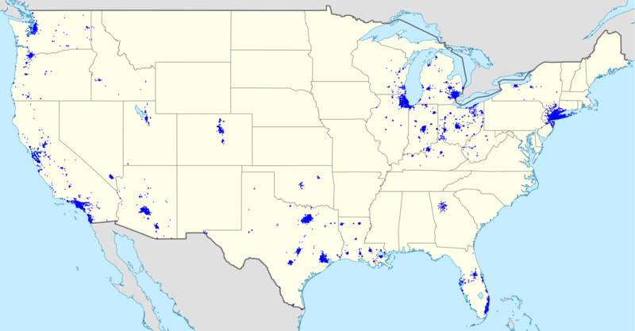
- Poor customer reviews including an average two stars (which is bad) for the following points:
  - Customer Service
  - Bank Rates
  - Online Experience
  - Fees & Charges
  - Overall Satisfaction
- Has had multiple companies in which they had invested heavily file bankruptcy recently (e.g. – K-mart, Enron & Global Crossing LTD)
- Still suffering from the deep losses heavy investments in the .com sector (which led to the merger with J.P. Morgan
- Heavily involved in foreign markets (particularly Argentina) that are currently experiencing turmoil
- Many complaints about the customer service some complaints include:
  - I.Hate.This.Company
  - They have the worst service.
  - Chase Bank Needs a remedial course in customer relations
  - WORST BANK EVER
- Charges higher fees than those of some other banks and credit unions
- Recently settled with US Treasury department for their willful violations of US Sanctions against countries that are state sponsors of terrorism.
- Facing increased competition by other banks and credit unions
- Received federal bailout money towards the beginning of the recession, has only recently begun to pay back the money given in the bailout.

OPPORTUNITIES
- Acquire smaller banks
- Student Loans
- Increase Branches in Utah
- Home Loans
- Car Loans
- Certificate of Deposit (CD's)
- Small Business Loans (SBA's)
- Credit Cards
- ATM's
- Home Affordable Refinance Program (HARP)

Threats
- Local Utah Banks
- Bank of America
- Zion’s Bank
- Bank of Utah
- Key Bank
- Wells Fargo Bank
- U.S. Bank
- Far West Bank
- First Utah Bank
- American Express Bank
- First National Bank

- Local Utah Credit Unions
- Utah Central Credit Union
- Deseret First Credit Union
- University Credit Union
- Utah First Credit Union
- Beehive Credit Union
- American United Family of Credit Unions
- Associated Federal Employees Credit Union
- Pacific Rails Credit Union
- Intermountain Credit Union
- TransWest Credit Union

RECOMMENDATIONS

The current condition of access into Chase is limited, because of the expansion of the Trax line. The recommendation would be to re-evaluate the access points as they are now and to be in the future to conclude a better access system.

The current standing of this location is that Mortgage Loan Officers have to be scheduled. This creates a difficulty for the customer when they arrive and don’t have an appointment. The recommendation would be to have Mortgage Loan Officers available during operating hours to better serve the customer.

